**Synge, John Millington (1871-1909)**

J. M. Synge (pronounced ‘Sing’) is best known for his plays, first staged at Dublin’s Abbey Theatre, that vividly depicted rural life in Ireland. His early intellectual interests resembled those of many modernists: he travelled throughout Europe as a young man, studying language at the Sorbonne in Paris and music in Germany and Italy; he read Darwin, Baudelaire, Mallarmé, and Nietzsche, among other innovative thinkers; he published in forward-thinking periodicals. The Irish myths and tales of Lady Gregory and the beauty of the Irish language, along with the urging of W. B. Yeats, whom he met in Paris in 1896, lured Synge home to his native Ireland, where he would study closely the language and culture of the rural west. His intimacy with the cultures of the Aran Islands and the west coast of Ireland, where he lived for short stretches of time, is recorded in *The Aran Islands* (1907) and *In Wicklow, West Kerry, and Connemara* (1911), both of which included images by J. B. Yeats. Synge’s ear for language and dialect helped him craft the poetic Hiberno-English that defined his dramatic dialogue, and his eye for the nuances of Irish peasant culture is evident not only in his stage directions, but also in his photographs and travel writing.

Synge is considered by many the major playwright of the Irish Dramatic Revival. He (along with Yeats, Gregory, and others) also helped to found and direct the Abbey Theatre. Throughout his short dramatic career, he courted controversy and shocked theatregoers. His first play, *The Shadow of the Glen* (1903), merges the folk and the modern: drawn from an Irish tale, it recalls Ibsen by concluding with a character named Nora leaving her husband. The audience, steeped in conservative political and religious mores, was outraged by this comedy, as they would be to varying degrees by his subsequent plays, *Riders to the Sea* (1904), *The Well of the Saints* (1905), and *The Tinker’s Wedding* (1909). The most notorious of these was his three-act comedy, *The Playboy of the Western World* (1907). This play chronicles the adventures of Christy Mahon, a young man who pretends to have murdered his father to impress Pegeen Mike and the local Mayo townsfolk. *Playboy* famously inspired riots among its audiences, who were shocked, according to many reports, by the mention on-stage of women’s undergarments. But the play also critiqued treasured notions of Catholicism and the Irish peasantry, skewered gender and domestic norms, and appeared to condone violence. Christy’s exodus from Mayo at the end of the play celebrates the artistic individualism evident in other real-life modernist exiles like Joyce and Beckett.

Synge died of Hodgkin’s disease at the age of 37, while in the midst of completing his final play, *Deirdre of the Sorrows* (1910). His collection *Poems and Translations* (1911) was published after his death by Cuala Press, the independent press run by Lily and Elizabeth Yeats. Synge powerfully influenced subsequent modern and contemporary drama, as evident in the tramps of Beckett, the dialect of Sean O’Casey, and the violent humor of Martin McDonagh.

**Paige Reynolds, College of the Holy Cross**

**List of Works**

Synge, John M. (1982) *J. M. Synge: The Collected Works*, gen. ed. Robin Skelton, 4 vols. Washington, D. C.: The Catholic University of America Press. Vol. 1, *Poems*, edited by Robin Skelton. Vol. 2, *Plays: Book I*, ed. Ann Saddlemeyer. Vol. 3, *Plays: Book 2*, ed. Ann Saddlemeyer. Vol. 4, *Prose*, ed. Alan Price.

----- (1983) *The Collected Letters of John Millington Synge*, ed. Ann Saddlemeyer, 2 vols., Oxford: Oxford University Press.

----- *My Wallet of Photographs: The Collected Photographs of J. M. Synge*, Manuscripts & Archives Research Library, Trinity College Dublin. http://digitalcollections.tcd.ie/home/index.php?DRIS_ID=MS11332_02

**References and Further Reading**

Burke, Mary. (2009) *‘Tinkers’: Synge and the Cultural History of the Irish Traveller*, Oxford: Oxford University Press.

Castle, Gregory. (2001) *Modernism and the Celtic Revival*, Cambridge: Cambridge University Press.

Grene, Nicholas. (1975) *Synge: A Critical Study of the Plays*, London: Macmillan.

Lonergan, Patrick (ed.). (2010) Synge and His Influences: Centenary Essays from the Synge Summer School, Dublin, Carysfort Press.

Mathews, P.J. (ed.). (2009) *The Cambridge Companion to J. M. Synge*, Cambridge: Cambridge University Press.

McCormack, W. J. (2009) *Fool of the Family: A Life of J. M. Synge*, London: Weidenfeld and Nicholson.

Roche, Anthony. (2013) *Synge and the Making of Modern Irish Drama*, Dublin: Carysfort.

**Recommended Illustrations**

**[Note:** Please use one of the two images of Synge (either the photograph or the sketch), but prioritize the photograph over the sketch. Please also prioritize the production photo and Synge’s photograph of the Aran Islanders. Use the J.B. Yeats image if possible, but it is a lower priority than the others.]

.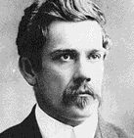

**John Millington Synge**

[available at: <http://www.folkworld.de/36/e/aran.html> and <http://thenewwildgeese.com/profiles/blogs/j-m-synge-and-the-playboy-of-the-western-world> ]

**OR**

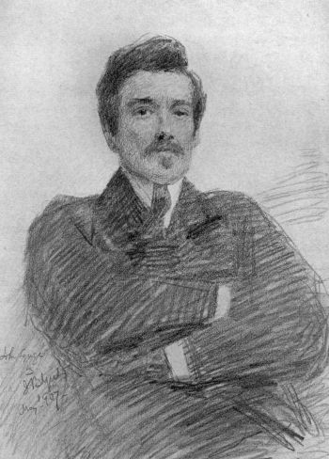

**John Millington Synge**

[Available at <http://www.gutenberg.org/files/19028/19028-h/19028-h.htm> AND <http://commons.wikimedia.org/wiki/File:John_Millington_Synge_-_Project_Gutenberg_eText_19028.jpg>]

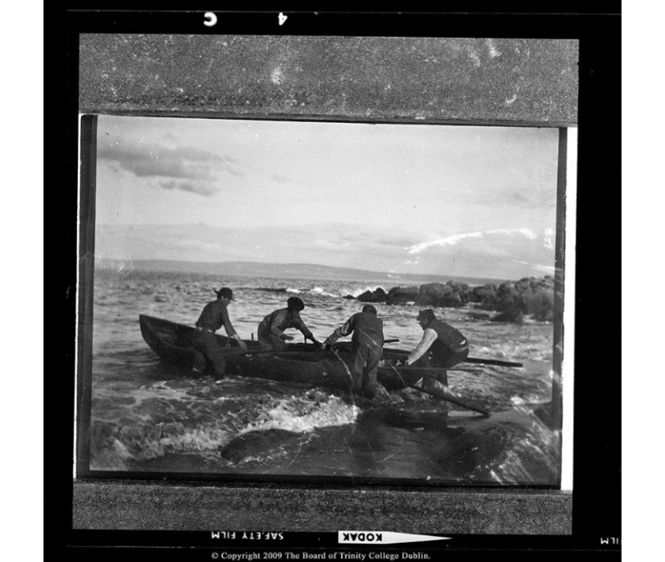

**Aran Islanders beaching their currach; photograph by John Millington Synge.**

[This image is from Synge’s *My Wallet of Photographs* and is available at Trinity College Dublin <http://digitalcollections.tcd.ie/home/index.php?DRIS_ID=MS11332_02> ]

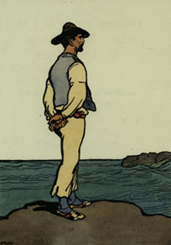

**Image by J. B. Yeats from Synge’s *The Aran Islands*, 1907.**

[Available at the National Gallery of Ireland: <http://www.nationalgallery.ie/en/Research/Library_and_Archives/World_Book_Day.aspx> ]

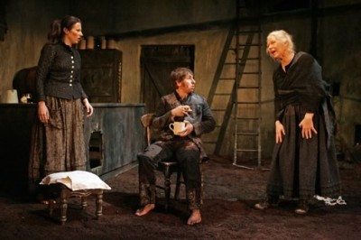

**The 2005/06 Druid Synge production of *The Playboy of the Western World*, with (from left to right) Catherine Walsh as Pegeen Mike, Aaron Monaghan as Christy Mahon, and Marie Mullen as the Widow Quin.**

[Available at: <http://www.druidsynge.com/gallery?set=playboy05>]